Lab No. 08
Name: Adil Khan | Roll no: BSCE-003
Submitted to: Sir.Mubasshir | Date: 9-12-2025

Objective: To implement and understand the working of Multilevel Inheritance

Multilevel Inheritance:
In multilevel inheritance a subclass is inherited from another subclass. It is not uncommon that a class is derived from another derived class as shown in the figure "Multilevel Inheritance". Multilevel Inheritance The class A serves as a base class for the derived class B, which in turn serves as a base class for the derived class C. The class B is known as intermediate base class since it provides a link for the inheritance between A and C.
class A{
//Do something
}
class B : public A{
//Do something
}
class C : public B{
//Do something
}

In this type of inheritance, a derived class is created from another derived class.
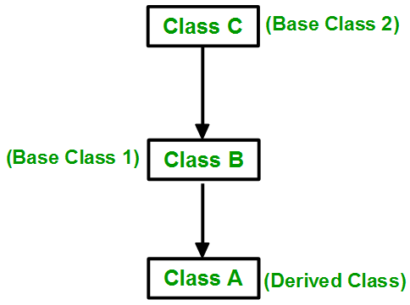

// C++ program to implement
// Multilevel Inheritance
#include<iostream>
using namespace std;
// base class
class Vehicle {
public:
Vehicle() {
cout << "This is a Vehicle\n"; }};
// first sub_class derived from class vehicle
class fourWheeler: public Vehicle
{ public:
fourWheeler() {
cout << "Objects with 4 wheels are vehicles\n"; }};
// sub class derived from the derived base class fourWheeler
class Car: public fourWheeler {
public:
Car() {
cout << "Car has 4 Wheels\n"; } };
// main function
int main() {
// Creating object of sub class will
// invoke the constructor of base classes.
Car obj;
return 0; }
Output
Lab tasks:
- Observe and Execute the above C++ program.
Program:

Output:
02.Write a C++ code that uses multilevel inheritance structure, based on any real life problem statement of your own choice.
Program:

Program:
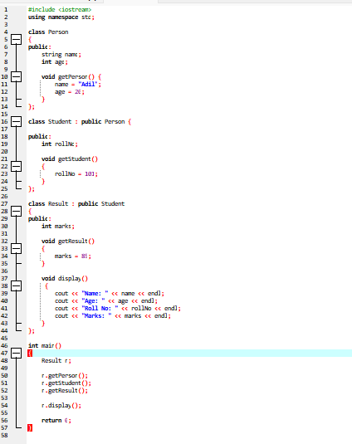

Output:



